NNEXURE-I

ANNEXURE REFERRED TO IN REPLY TO PARTS (a) TO (c) OF UNSTARRED QUESTION NO. 867 TO BE ANSWERED IN THE LOK SABHA ON 06.02.2020.

***************

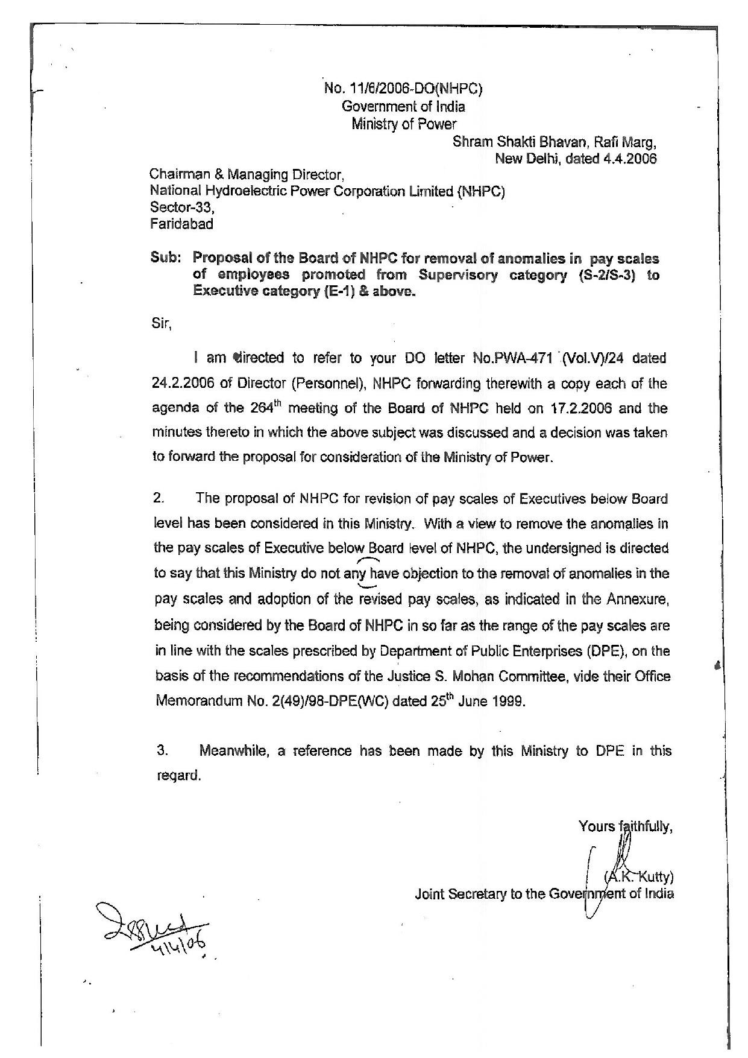



REVISION OF TBESCALES OF PAY OF THE EXECUTIVES OF

NATIONAL HYDROELECTRIC POWER CORPORATION LIMITED

|  |  |  |  |  |
| --- | --- | --- | --- | --- |
| Grade ,  code | DPE's Model Scales (Mohan Committee RecolilIIlendations) | Grade code | Existing scales of  NHPC | Seal.es now proposed |
|  | wef 1.1.1997 |  | wef 1.1.1997 |  |
| E-0 | 6500-200- 11350 |  | Not exsiting |  |
| E-1 | 8600-250-14600 | E-1 | 8000-225-13400 | 8000-290-300-330(2}·  350-360-370-390-4 10-  420-440-460-470-480- |
| 13400 | |
| E-4 | 10750-300-16.750 | E-2 | 8600-250-14600 | 8600-330(2)-350-370-  380-400-420-430-450-  470-490-510-530-540-  14600 |
|  |  | E-2A | 10750-300-16750 | 10750-420-430-450-  470-490(2)-530-540(3)-  550(2)-16750 |
| E-3 | l3000-350-L8250 | E-3 | 14500-350-18700 | 13750-550-575-600-  610-620-625-685(2)-  18700 |
| E-4 | 14500-350-18700 | E-4 | 16000-400-20800 | 16000-660-685(4)-  700(2)-20800 |
| E-5 | 16000-400-20800 | E-5 | 17500-400-22300 | 17500-630-685(2)-  700(4)-22300 |
| E-6 | 17500-400-22300 | E-6 | 18500-450-23900 | 18500-700(2)-730-750-  780-850-890-23900 |
| E-7 | 18500-450-23900 | E-7 | 20000-475-25700 | 19500-750-810-845-  880-910-945-960-25600 |
| E-8 | 20500-500-26500 | E-8 | 20500-500-26500 | 20500-670(2)-850-900-  950-980-980(2)-26500 |
| E-9 | 23750-600-28550 | E-9 | 23750-600-28550 | 23750-900-950-980(2)-  990-28550 |



ANNEXURE-II

ANNEXURE REFERRED TO IN REPLY TO PARTS (a) TO (c) OF UNSTARRED QUESTION NO. 867 TO BE ANSWERED IN THE LOK SABHA ON 06.02.2020.

***************



 